Portfolio Page

Definition
# Source: AI Source: Provided by: [Data Path: Persons Table -> ID Column: 1, Name_En Column: Motasem Essam] -> From: [Chatgpt (GPT‑5 Mini)] on [2/12/2026]
A Portfolio Page is a web page that showcases your work, projects, skills, or achievements to demonstrate what you can do.

Simple Definition
# Source: AI Source: Provided by: [Data Path: Persons Table -> ID Column: 1, Name_En Column: Motasem Essam] -> From: [Chatgpt (GPT‑5 Mini)] on [2/12/2026]
Portfolio Page = a page that displays your best work to impress clients, employers, or visitors.

What a Portfolio Page Usually Includes
# Source: AI Source: Provided by: [Data Path: Persons Table -> ID Column: 1, Name_En Column: Motasem Essam] -> From: [Chatgpt (GPT‑5 Mini)] on [2/12/2026]
- Project samples – examples of your work (websites, designs, photos, apps, etc.)
- Descriptions – details about each project (what it is, tools used, results)
- Images / Videos – visual proof of your work
- Skills used – technologies or abilities demonstrated
- Links (optional) – live project or GitHub/demo links
- Testimonials (optional) – feedback from clients or employers

Purpose of a Portfolio Page
# Source: AI Source: Provided by: [Data Path: Persons Table -> ID Column: 1, Name_En Column: Motasem Essam] -> From: [Chatgpt (GPT‑5 Mini)] on [2/12/2026]
- Show your skills and experience
- Prove your quality of work
- Attract clients, freelance jobs, or employment
- Build professional credibility

Examples
# Source: AI Source: Provided by: [Data Path: Persons Table -> ID Column: 1, Name_En Column: Motasem Essam] -> From: [Chatgpt (GPT‑5 Mini)] on [2/12/2026]
- Web developer → shows websites or apps built
- Graphic designer → displays logos, posters, branding work
- Photographer → shows photo collections
- Writer → shows articles or published work

Difference Between Portfolio Page and About Page
# Source: AI Source: Provided by: [Data Path: Persons Table -> ID Column: 1, Name_En Column: Motasem Essam] -> From: [Chatgpt (GPT‑5 Mini)] on [2/12/2026]
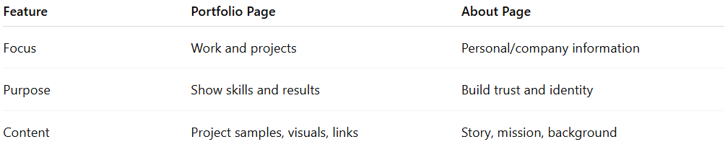
Feature | Portfolio Page | About Page
Focus | Work and projects | Personal/company information
Purpose | Show skills and results | Build trust and identity
Content | Project samples, visuals, links | Story, mission, background

